Online Food order and delivery system

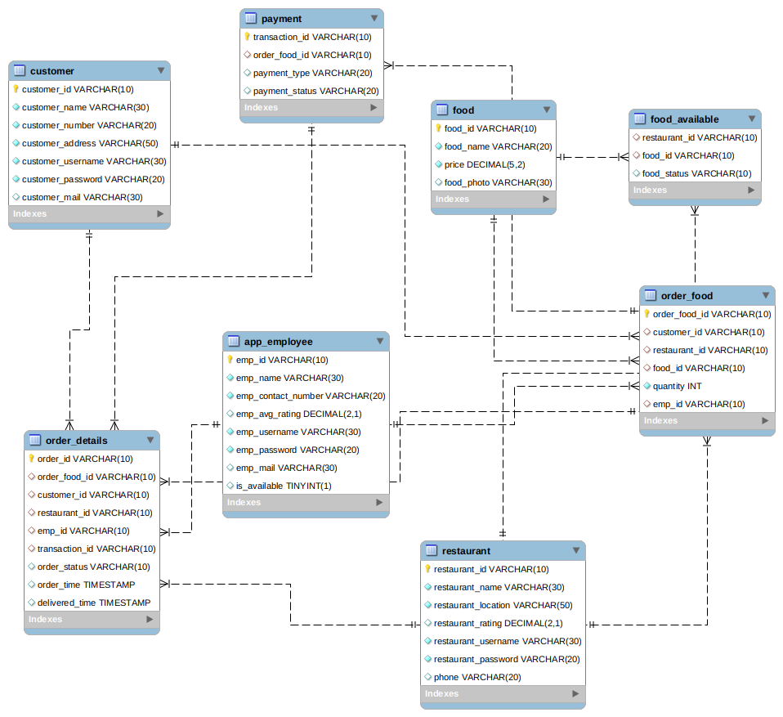

There are three kinds of user:

- Restaurant
- Customer
- App Employee

The restaurants will be able to resgitser themselves in the application and login using username and password. They will be able to upload food items they sell, take orders, assign delivery person and deliver food.

The customer can see different food and restaurents, order food, make payment, get details about their order, delivery status and rate the delivery person and the restaurant.

The app employee(delivery person) will accept order from the restaurant and deliver it.

There are 8 tables:

- Restaurant: The restaurant table contains information about the restaurant, its name, username, password, location and rating.

- Customer : The table contains information about the student like its name, number, address, username, password and mail id.

- App Employee: The app employee table conatins information about the delivery person like its name, rating, username, password, mail, phone number and is it availabe or not.

- Food: The food table contains the food name, its price and its photo.

- Food_available: Its conatins information that whether a food is available or not in the restaurant.

- Order food: Conatins information about the order being placed like resturant id, food id, quanity, etc.

- Payment: Conatins information about the payment done.

- Order_details: This table conatins information after order placed like customer id, restaurant id, emp id, order status, order time, delivery time.

